# SSH Extras—SFTP and SCP

Note: This lab requires two machines running either Linux or Windows. It can be done with VMs, host machines, cloud VMs, or any combination.

## Secure FTP (SFTP)

As part of the OpenSSH client, both Linux and Windows usually include SFTP and SCP. You can use either one to transfer files between your local host and a remote host. The SFTP protocol is used the same as the old, unencrypted FTP (don’t use FTP) but it is encapsulated in an encrypted SSH session. SFTP has all the functions of the old FTP protocol but uses modern encryption.

### Connecting

To create an SFTP session, use the the same syntax as SSH, but use sftp instead of ssh. This is an example of connecting from a Windows host to an AWS VM.

This is an example of connecting from a local Ubuntu VM to a local Kali VM, using passwords instead of certificates.

### Interactive mode

A normal SSH connection allows you to execute commands in the shell of the remote machine. SFTP normally works in interactive mode, where you run commands made available through the SFTP application. These commands are the same as those available through the old FTP application. To see the SFTP commands that are available, type ‘help’.  
<snip>

If the description of a command includes the term, remote, it is executed on the remote machine (the one you connected to.) If it includes the term, local. It works on the machine you used to start the SFTP session.

#### Commands that execute on the remote machine

cd, chgrp, chmod chown, df, ln, ls, mkdir, pwd, rename, rm, rmdir.

Except for rename (we used mv), all these commands are the familiar file system shell commands that we used in Linux. These commands also work with Windows—SFTP was originally written for Linux and then ported to Windows, so it uses Linux-style command names.

#### Commands that execute on the local machine

lcd, lls, lmkdir, lpwd

These commands allow you to discover information and create directories on the local file system. They are the same as the familiar Linux commands but prefixed with ‘l’ for local.

#### Commands that move files

get will download a file from the remote machine to the local machine.

put will upload a file from the local machine to the remote machine.

These are the commands that do all the work.

#### Quit SFTP

bye, exit, and quit will all break the connection and quit SFTP.

### Example Download

### Example upload

# Hand in

Submit screenshots of uploading and downloading files between two hosts (host and AWS VM, host and local VM, two local VMs, whatever.)

## Secure Copy (SCP) Optional

Secure copy (SCP) was written to expand the Linux plain old copy (cp) command so that it could be used between a local and a remote host. Although SCP has been deprecated, it is still available on many Linux and Windows versions of OpenSSH.  
<https://lwn.net/Articles/835962/>   
<https://www.redhat.com/en/blog/openssh-scp-deprecation-rhel-9-what-you-need-know>

The regular copy command uses this syntax:  
cp [source file] [destination file]

The difference with SCP is that you specify the computer you are copying to or from using the same header that you use for SSH, [user]@[ip address or computer name]:. Examples are john@centos: or john@192.168.12.34:. Note the colon between john@centos and the file name!

So, if I want to copy a file (called file, for example) from my local computer to a remote computer, I might use:  
scp ~/file user@remotecomputer:file

If I want to copy a file from the remote computer to my local home directory, I might use:  
scp user@remotecomputer:file ~/file  
  
Let’s make a file on Kali and then use scp to copy it to CentOS. 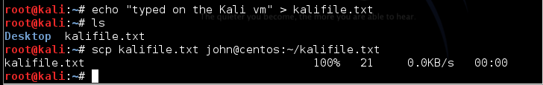

The file is indeed on the CentOS VM. 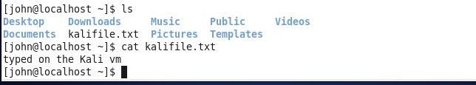

Now, let’s create a file on the CentOS VM, and then use scp on the Kali VM to fetch it. Since the source file is on the CentOS VM, we use john@centos: before the source file name.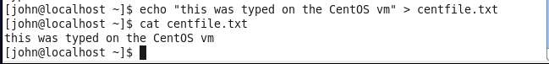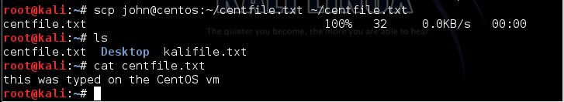

## SCP on Windows

Hurray! As of the April 2018 update to Windows 10 (version 1803) OpenSSH is now installed on Windows by default. It is the same code that Linux uses, so it works the same way.  
